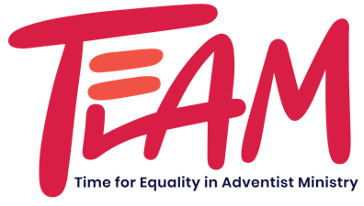

Re-Application for Previous TEAM Scholarship Recipients ONLY

Name: Date:

Email: Age: Nationality:
Marital status: Number of dependents:
University: Area of study & degree sought:
Present year of study: GPA:
Date when scholarship is needed:
Date of graduation:
Yearly tuition costs:
Yearly room & board:
Other expenses:
Total expenses:
Yearly income: Financial support:
Dates and Amounts of TEAM Scholarships received in the past:

Goals:

Return this completed re-application along with a copy of your grades, and
one recommendation to: applicationforteam@gmail.com
Reference Form
TEAM (Time for Equality in Adventist Ministry)
Women in Ministry Scholarship Fund

Name of Applicant: ________________________________________________________________________

Please complete this form on the computer and email it as soon as possible directly to applicationforteam@gmail.com or mail to: TEAM Scholarship Review Committee, PO Box 7816, Langley Park, MD 20787-7816

- How long have you known this person, and in what capacity?

- What are her strengths, assets, and skills?

- In what areas does she need to grow?

- What contributions has she made in school, work, church, or the community?

- What reservations, if any, do you have about this student?

- List additional information you feel the review committee should consider. Use additional pages as necessary.

Print name and position/title: _______________________________________________________________

Relationship to applicant (mark one): pastor/head elder professor employer/supervisor

Signature: ____________________________________________________ Date: __________________

